Chiltern Region Summer Meet

At

Hertford Club Site

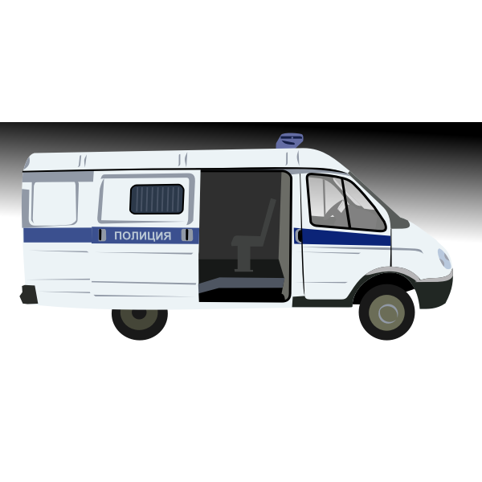Mangrove Road

Hertford

**Let’s all meet up again**

**Come and join us**

SG13 8AL

24th -27th June 2021

**All pitches must be booked with Julie on 07939 010808**

A unit 2 adults & 2 children

Thursday night £10 extra adult £1 Lone camper £9

Friday & Saturday night per night £13 extra adult £2 lone camper £11

Sunday night £9 extra adult £1 Lone camper £8

Electric pitches

£4.70 per night