+Apps Court Farm, Surrey (29th July to 12th Aug 2019)
With over 80 acres of rolling grassland, Apps Court Farm is a rare commodity in South West London: a fabulous place to pitch a tent or a caravan within easy reach of the West End and tourist attractions in the South East, including:

- Hampton Court Palace,
- Windsor Castle,
- Chessington World of Adventures,
- Brooklands Car Museum,
- Mercedes-Benz World,
- Local Leisure centre with swimming pool,
- Bushy Park,
- Legoland.
​
We have space for motorhomes, campervans, touring caravans and tents. We have toilets and showers which are free to use and have chemical waste points and fresh drinking water taps located around the campsite.
​​
- Wide access gates with entrance and exit gates inset at an angle to assist turning
- Butane and propane gas cylinders sold on site
- Showers and toilets, including facilities for disabled visitors
- Riverside location with peaceful open views
- 2 large onsite well stocked fishing lakes
- 24 hour security and helpful staff
- Archery range onsite
- Social tent onsite
- Onsite car boot, (Sundays)

We also have access to the River Thames as we back on to the towpath at Sunbury Lock which makes us ideally located for river walks and cycle rides. There is also a lovely river pub within easy walking distance that sells great food.

The weekend of the 10th and 11th Aug is the Sunbury Regatta, over 100 races on the Thames as well as many land based events all within a stone’s throw of the campsite. There is also a firework display, which you can see from the comfort of your camping.

Pre-booking advisable Contact Tracey on 07557914324 to book. If you do not pre-book it is advisable to contact Tracey prior to arrival to ensure there are still pitches available
There will be NO access to site on AUGUST 4th until after 4.00 pm due to a road closure for a cycle road race

​
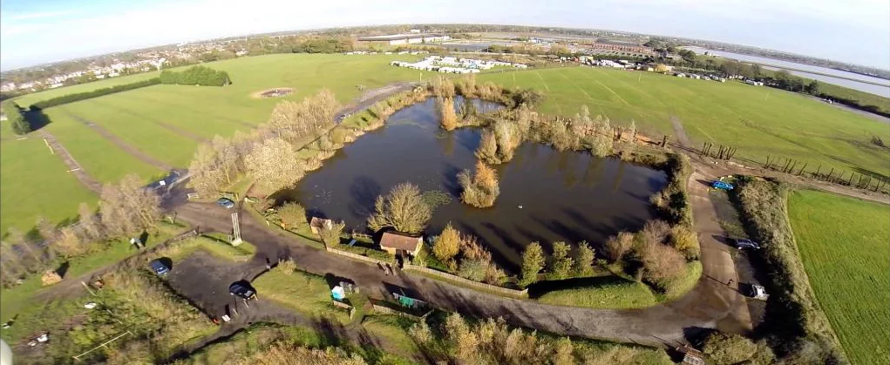
Apps Court Farm, Hurst Road, Walton-on-Thames, Surrey, KT12 2EG

