GALLERY

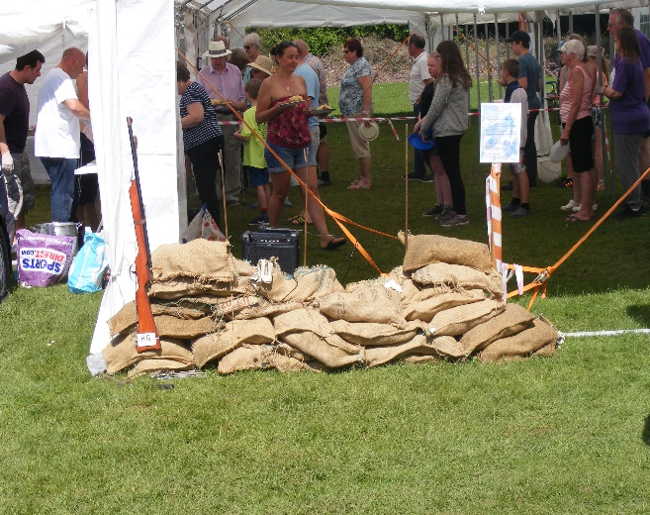 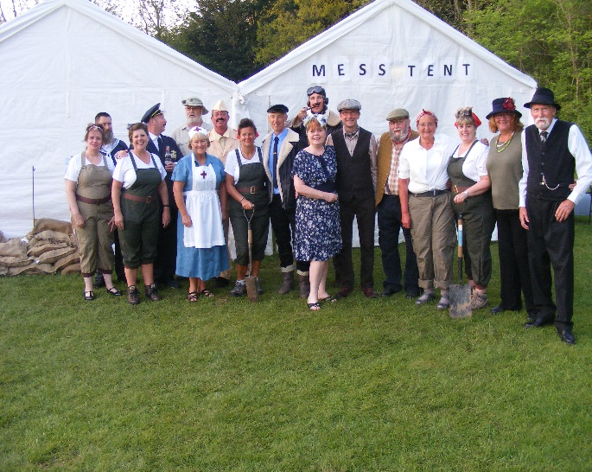 May Day Meet Friday 4th to Monday 7th May Theme Battle of Britain
65 units were in attendance for this meet (A record for our May Day Meet) on a field which was initially very wet which meant that pitch allocation was very hard and then enjoyed what turned into a very hot sunny weekend. It was so hot that on Sunday afternoon the games were cancelled to avoid people getting sunstroke. We had a meal based on the available foods during the war (Corned Beef Hash) and free drinks. I believe everyone had a great time 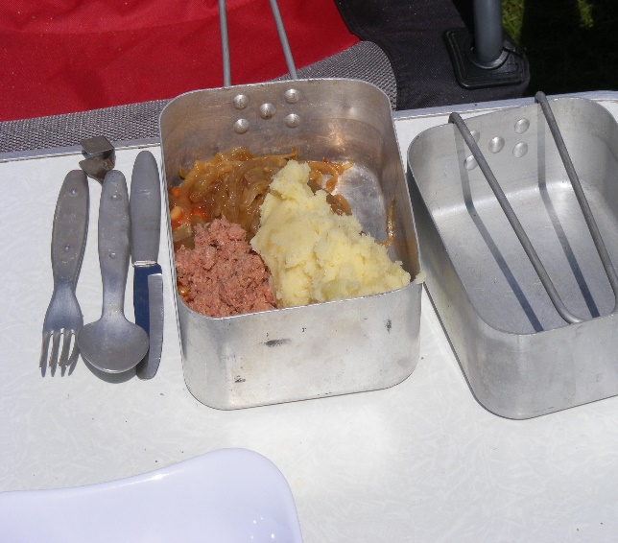 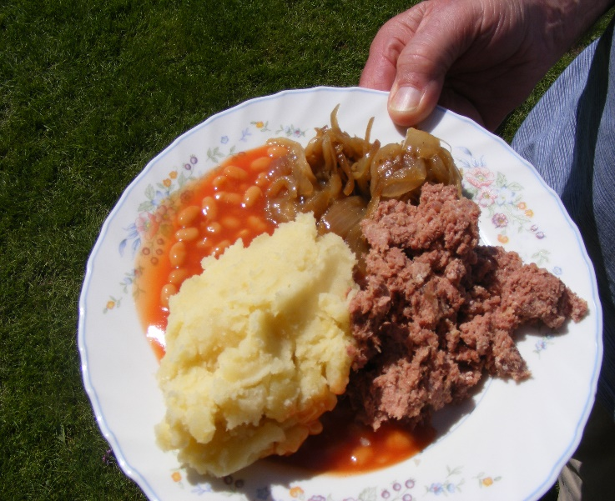Nobody really wanted to go home